LAB1_QuadraticEquatinos

import java.util.Scanner;

class QuadraticEquations

{

public static void main(String args[])

{

double a,b,c,D;

double r1,r2;

Scanner in = new Scanner(System.in);

System.out.println("Enter the constants a,b and c of the quadratic equation a(x)^2+b(x)+c=0 : ");

a = in.nextDouble();

b = in.nextDouble();

c = in.nextDouble();

System.out.println();

System.out.println("Input Quadration Equation : "+a+"(x)^2 + "+b+"(x) + "+c+" = 0");

System.out.println();

D = (b*b)-(4*a*c);

if(D>0)

{

System.out.println("Roots are real and unequal since Discriminant = "+D);

r1 = (-b + Math.sqrt(D))/(2*a);

r2 = (-b - Math.sqrt(D))/(2*a);

System.out.println();

System.out.println("Roots of the quadratic equation are "+r1+" and "+r2);

}

else if(D==0)

{

System.out.println("Roots are real and equal since Discriminant = "+D);

r1 = r2 = (-b)/(2*a);

System.out.println();

System.out.println("Roots of the quadratic equation are "+r1+" and "+r2);

}

else

{

System.out.println();

System.out.println("Roots are unreal since Discriminant = "+D);

}

}

}

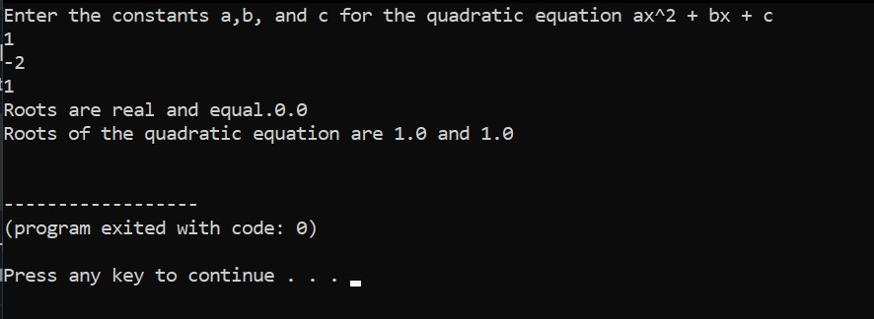

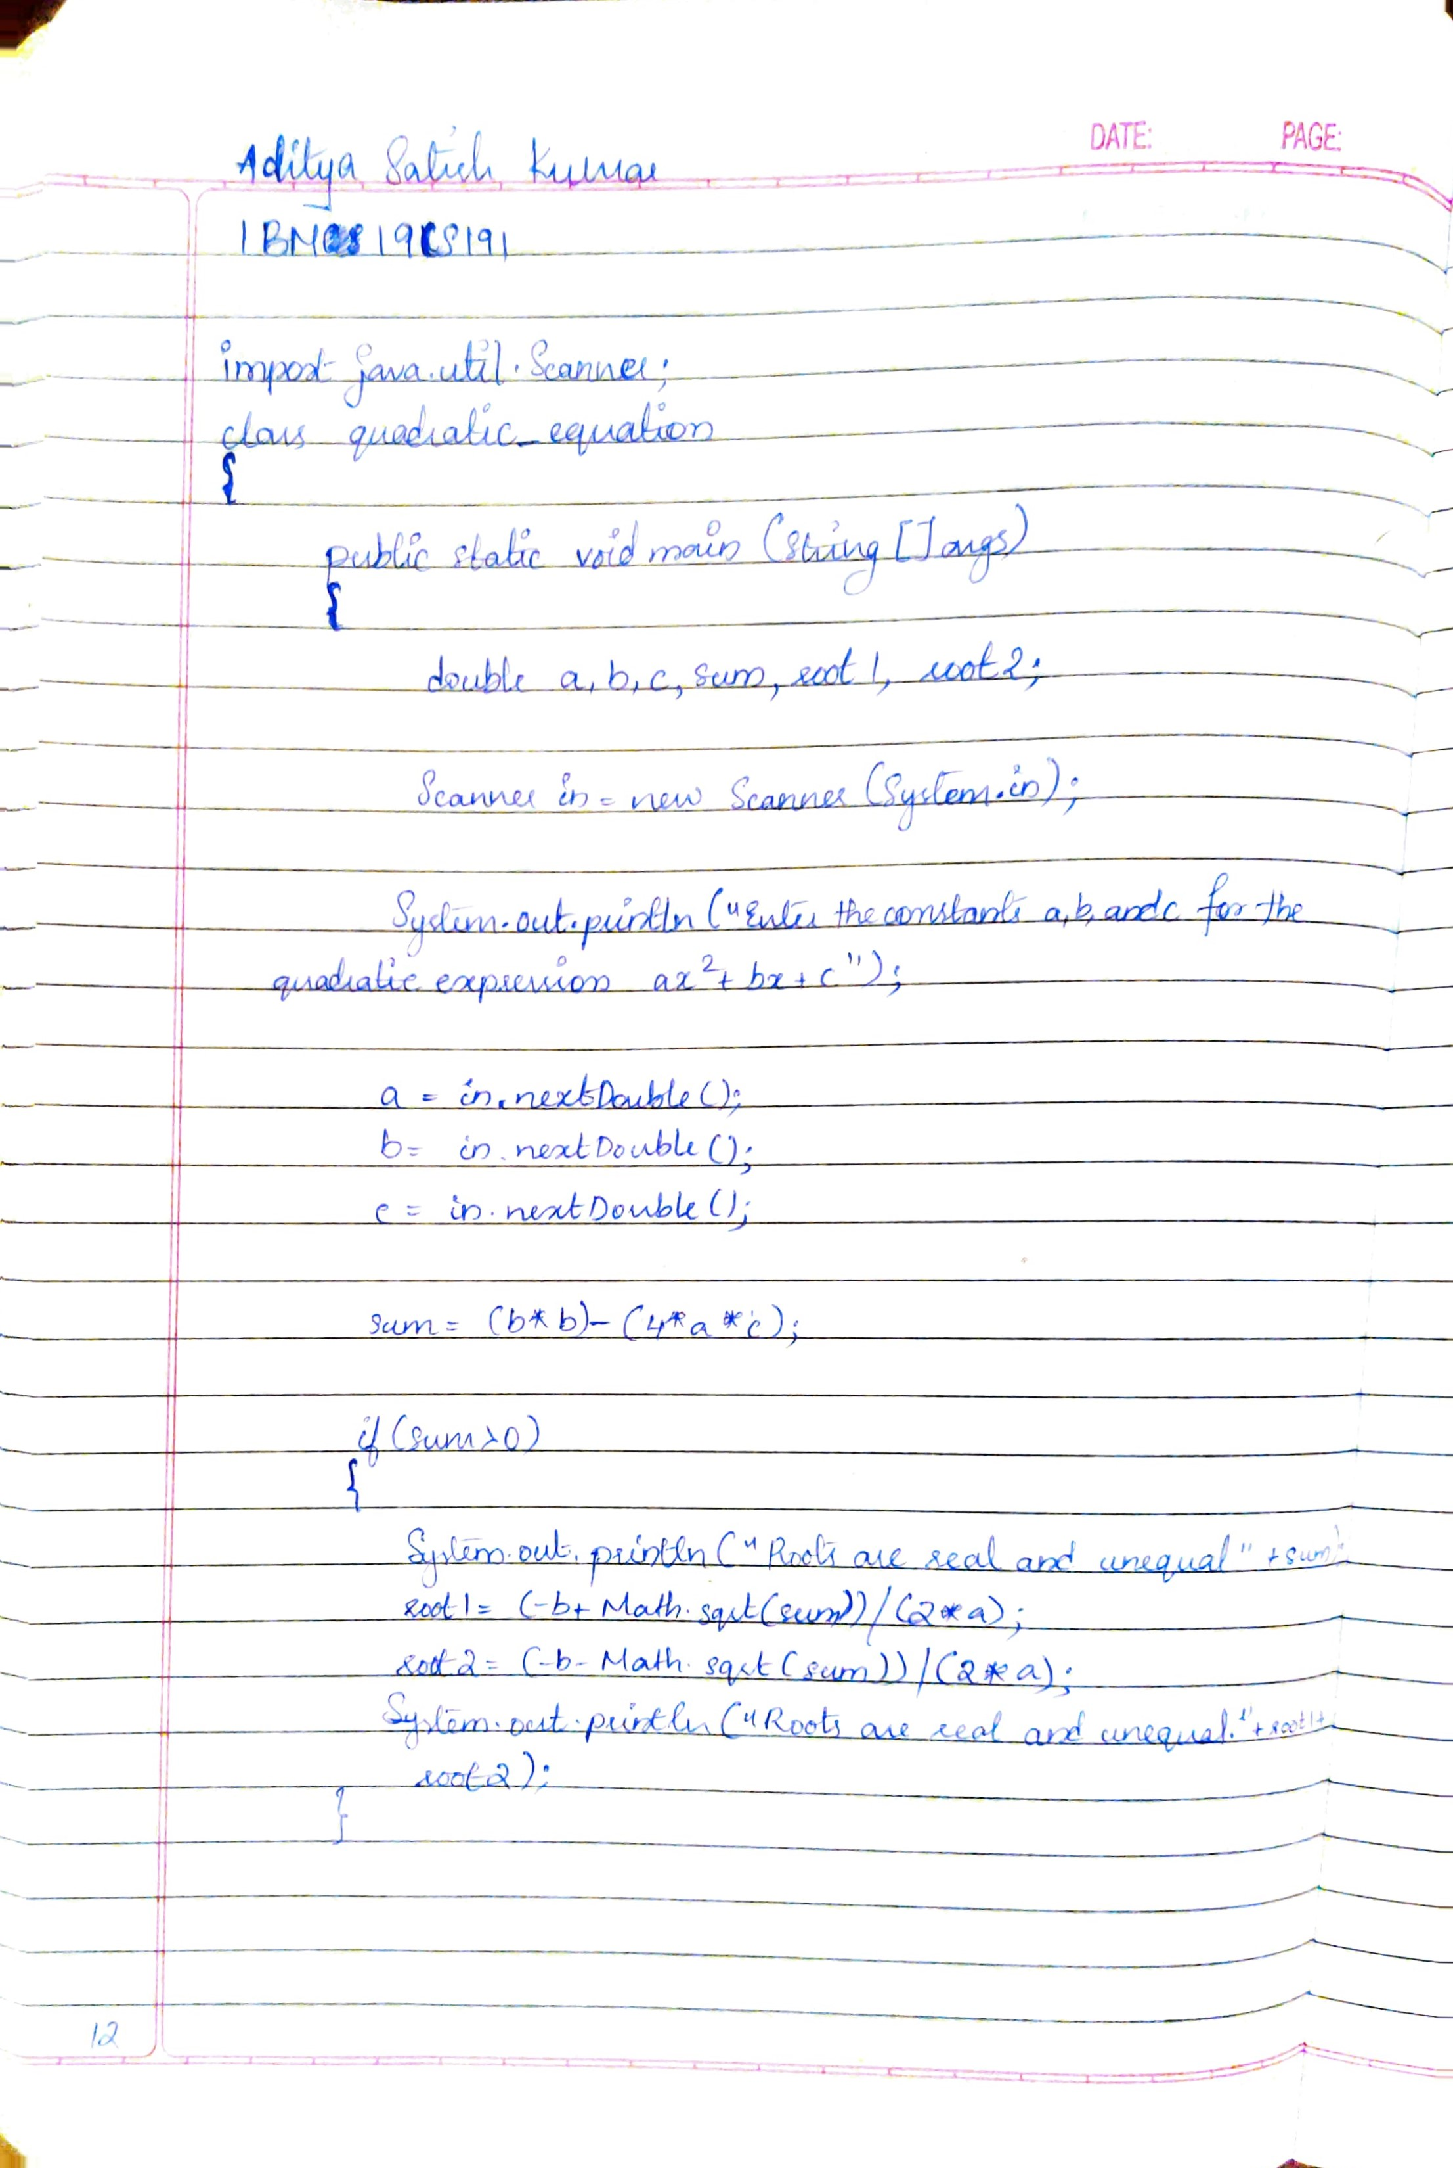

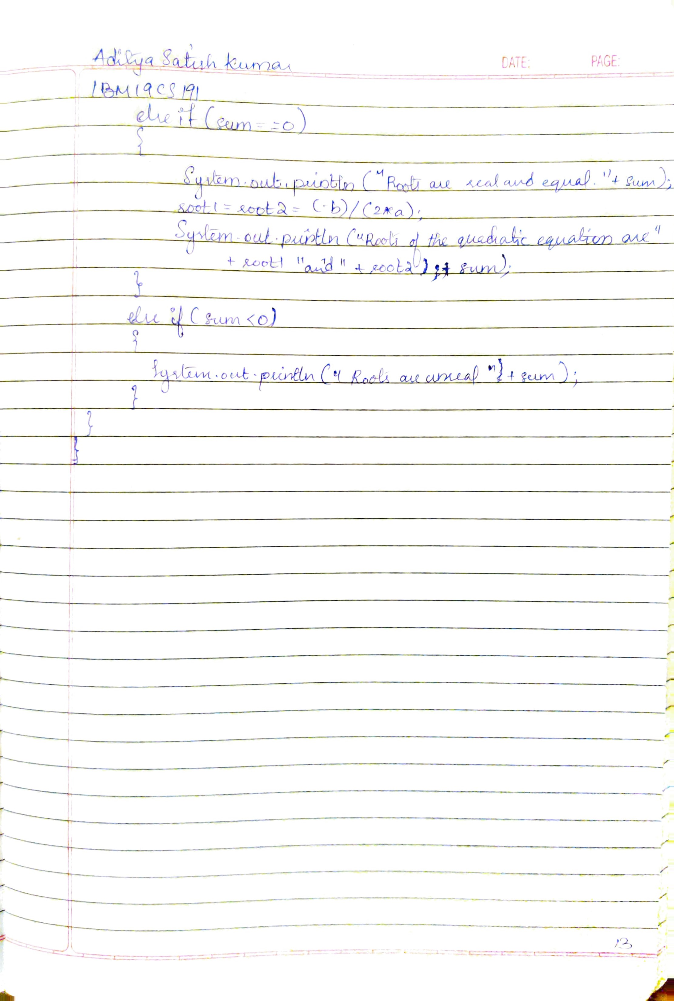

LAB2_StudentSGPA

import java.util.Scanner;

class Student{

Scanner ss= new Scanner(System.in);

String USN;

String Name;

int credits[]= new int[5];

double marks[]= new double[5];

int points[]= new int[5];

double SGPA;

int totalCredits= 0;

void getDetails(){

System.out.println("Enter the Student USN: ");

USN= ss.nextLine();

System.out.println("Enter the name of the Student: ");

Name= ss.nextLine();

for(int i=0;i<5;i++){

System.out.println("Enter the amount of Credits for Subject " + (i+1) + ": ");

credits[i]= ss.nextInt();

totalCredits+= credits[i];

System.out.println("Enter the Marks obtained by the student for Subject " + (i+1) + " out of 100: ");

marks[i]= ss.nextDouble();

}

}

void printDetails(){

System.out.println("Student USN: " + USN);

System.out.println("Student Name: " + Name);

for(int i=0;i<5;i++){

System.out.println("Subject " + (i+1) + " : Credits: " + credits[i] + " --> Marks: " + marks[i]);

}

System.out.println("SGPA of " + Name + " is: " + (double)(SGPA/totalCredits));

}

void sumSGPA(){

for(int i=0;i<5;i++){

if(marks[i] >= 91){

points[i] = 10;

}

else if(marks[i] >= 81){

points[i] = 9;

}

else if(marks[i] >= 71){

points[i] = 8;

}

else if(marks[i] >= 61){

points[i] = 7;

}

else if(marks[i] >= 51){

points[i] = 5;

}

else if(marks[i] >= 41){

points[i] = 4;

}

else{

points[i] = 0;

}

SGPA += (points[i]*credits[i]);

}

}

}

public class LAB2 {

public static void main(String args[]){

Student s1= new Student();

s1.getDetails();

s1.sumSGPA();

s1.printDetails();

}

}

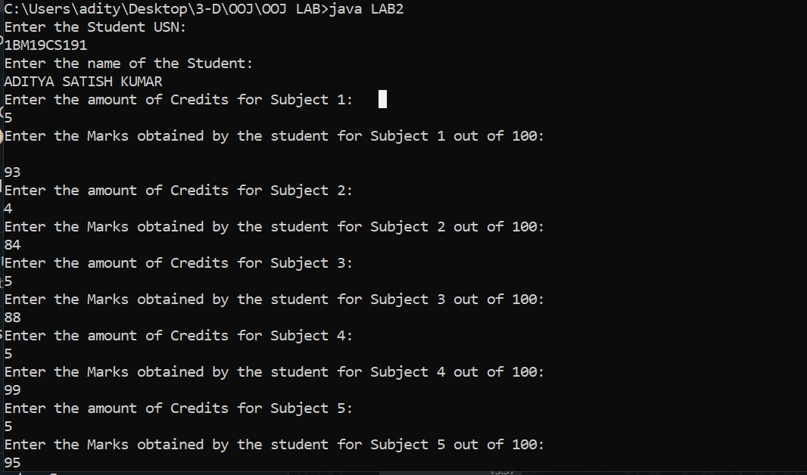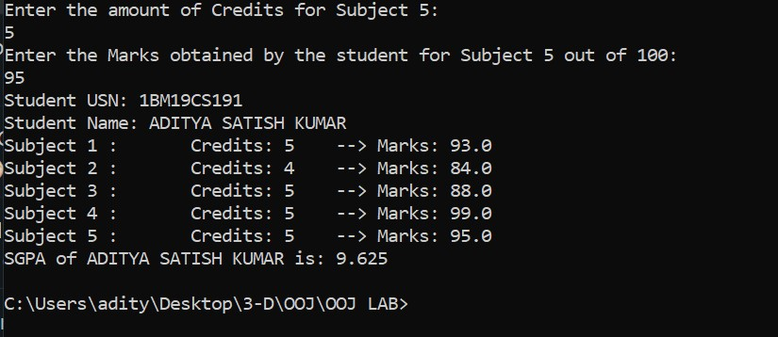

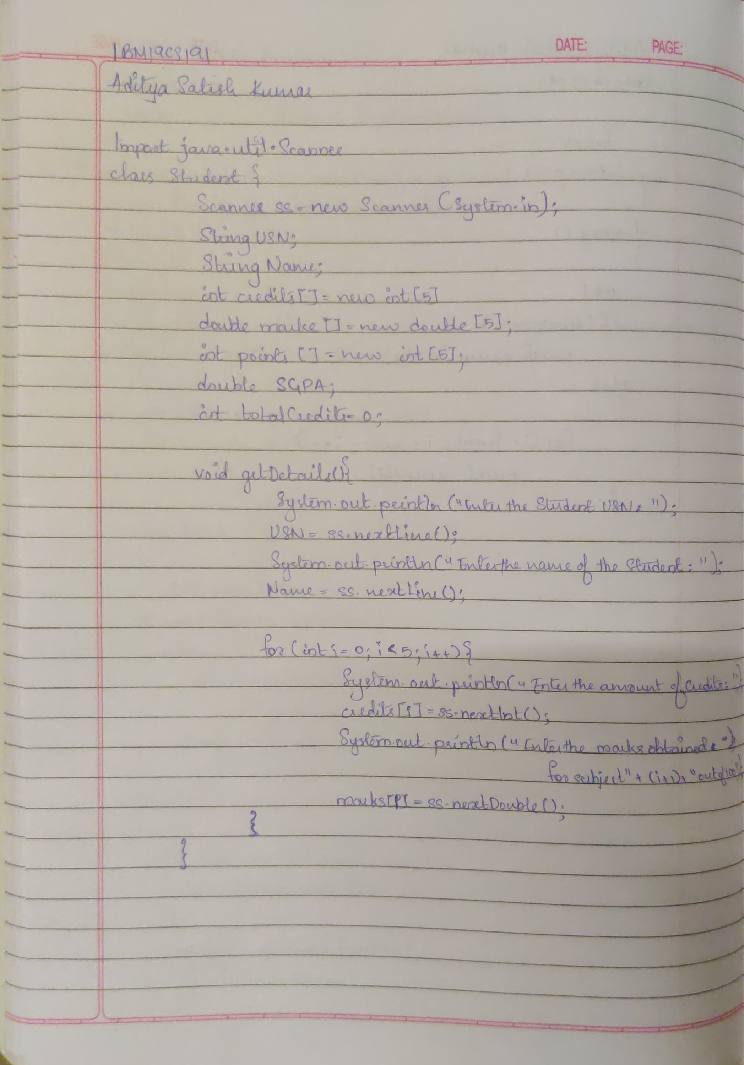

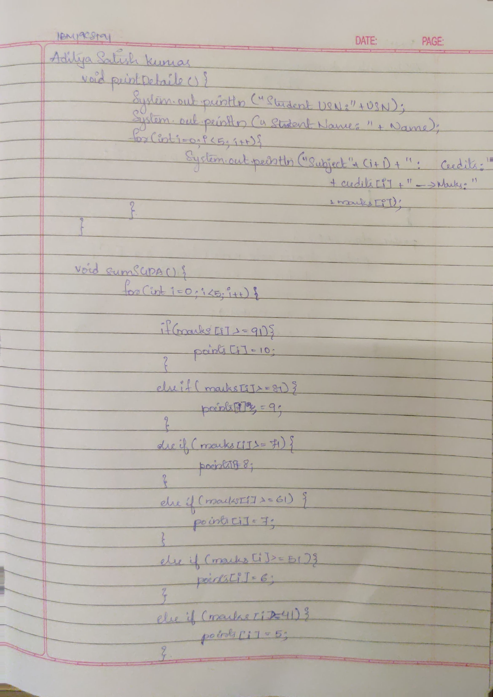

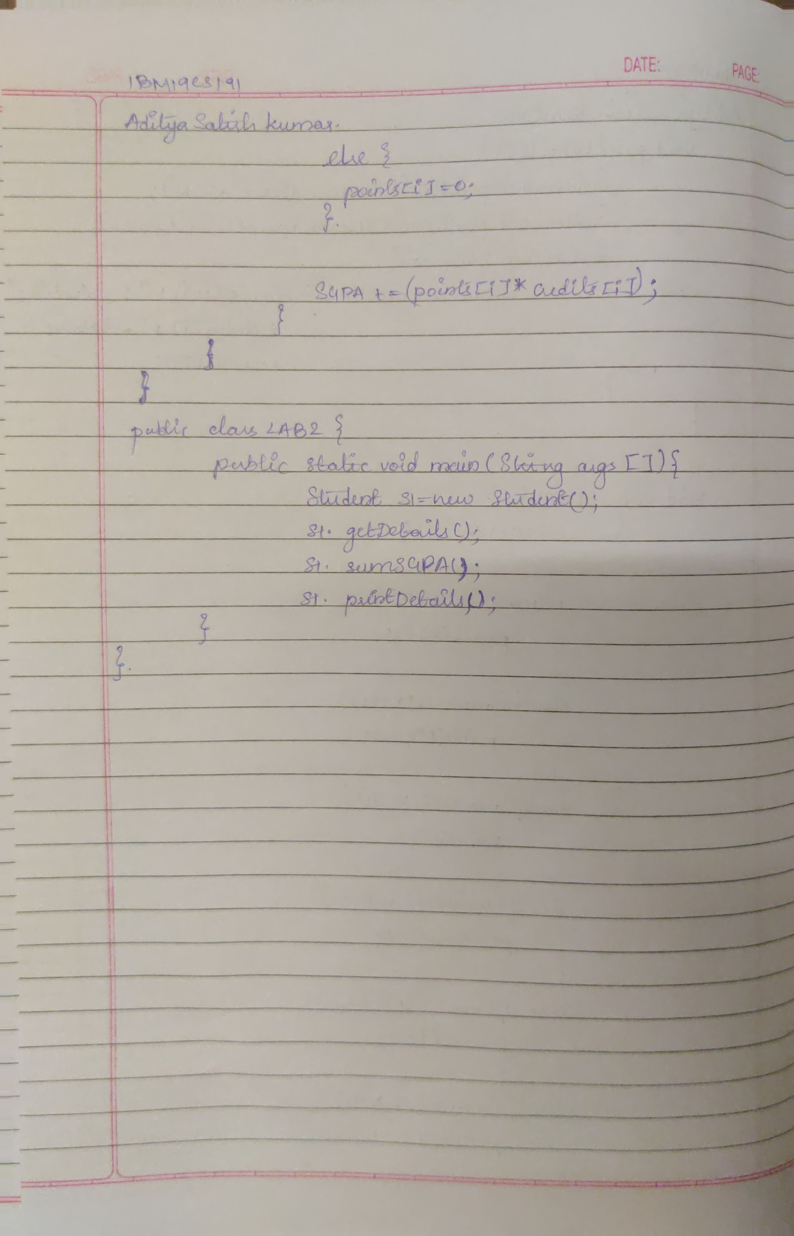

DATE:

LAB3_BookDisplay

import java.util.*;

import java.lang.*;

class Book{

String name, author;

double price;

int num_pages;

Scanner in = new Scanner(System.in);

Book(){

System.out.println("Enter name of book: ");

name = in.nextLine();

System.out.println("Enter name of author: ");

author = in.nextLine();

System.out.println("Enter price of book in Rs: ");

price = in.nextDouble();

System.out.println("Enter number of pages in the book: ");

num_pages = in.nextInt();

}

void show(){

System.out.println("Name: " + name);

System.out.println("Author: " + author);

System.out.println("Price: " + price);

System.out.println("Number of pages: " + num_pages);

}

public String toString(){

return name + ", By " + author + " for Rs." + price + " and has " + num_pages + " pages";

}

public static void main(String[]args){

Scanner in = new Scanner(System.in);

int n, x;

System.out.println("Enter number of books to be created: ");

n = in.nextInt();

Book B[] = new Book[n];

for(int i=0;i<n;i++) {

System.out.println("Book " + (i+1));

B[i] = new Book();

System.out.println();

}

for(int i=0;i<n;i++) {

System.out.println("Book " + (i+1));

System.out.println(B[i]);

System.out.println();

}

do {

System.out.println("Enter the book number whose details you want to display: ");

x = in.nextInt();

}

while(x < 1 && x > n);

B[x-1].show();

}

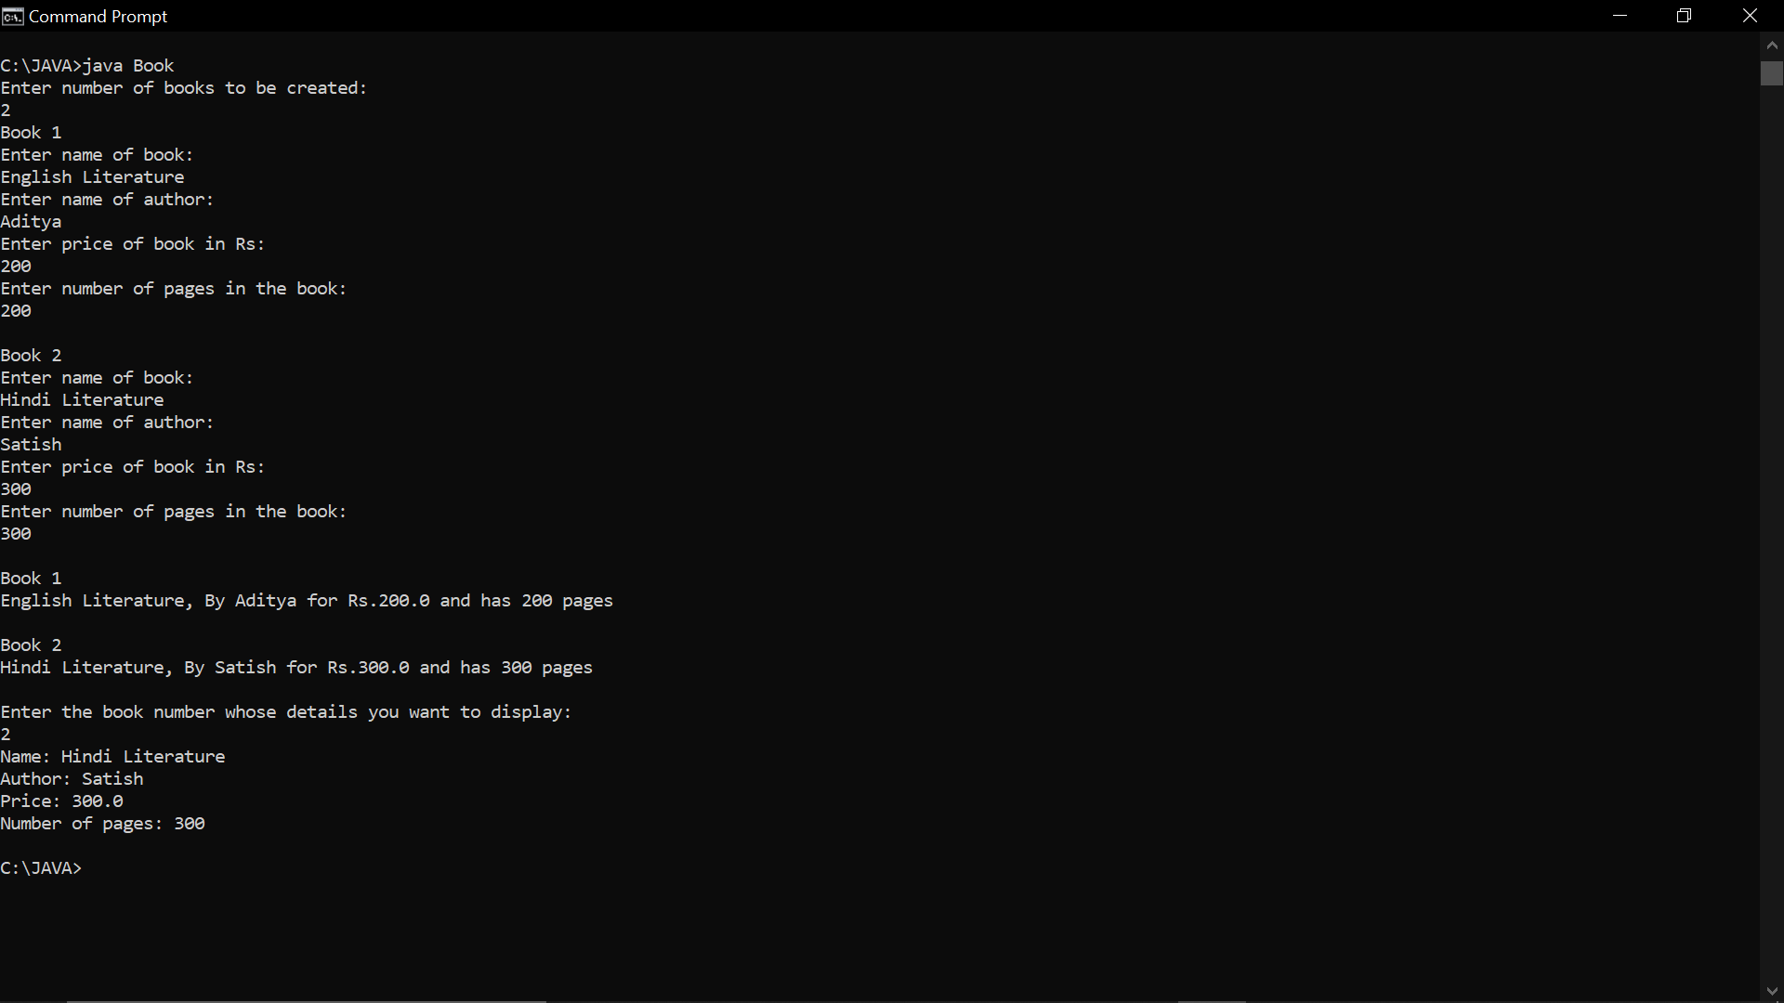}

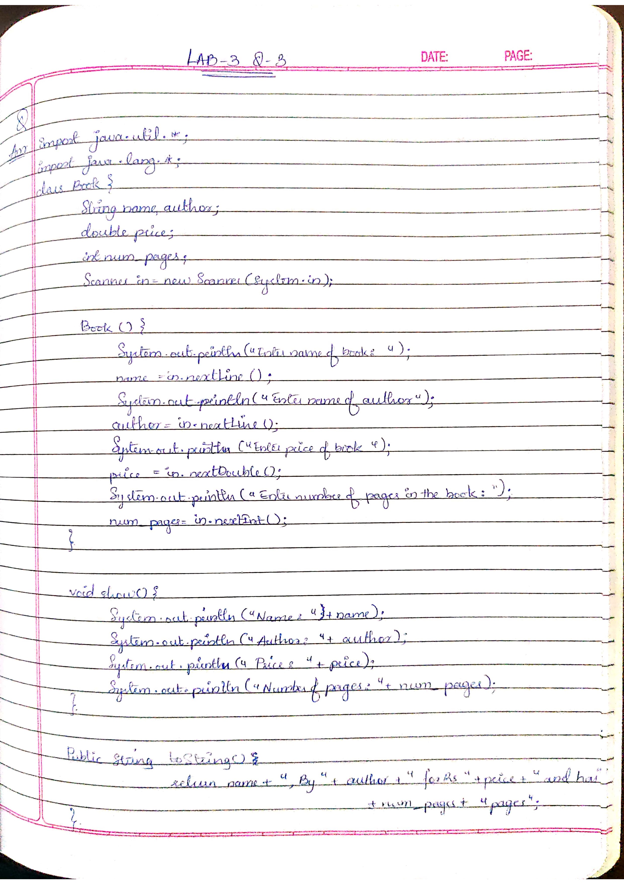

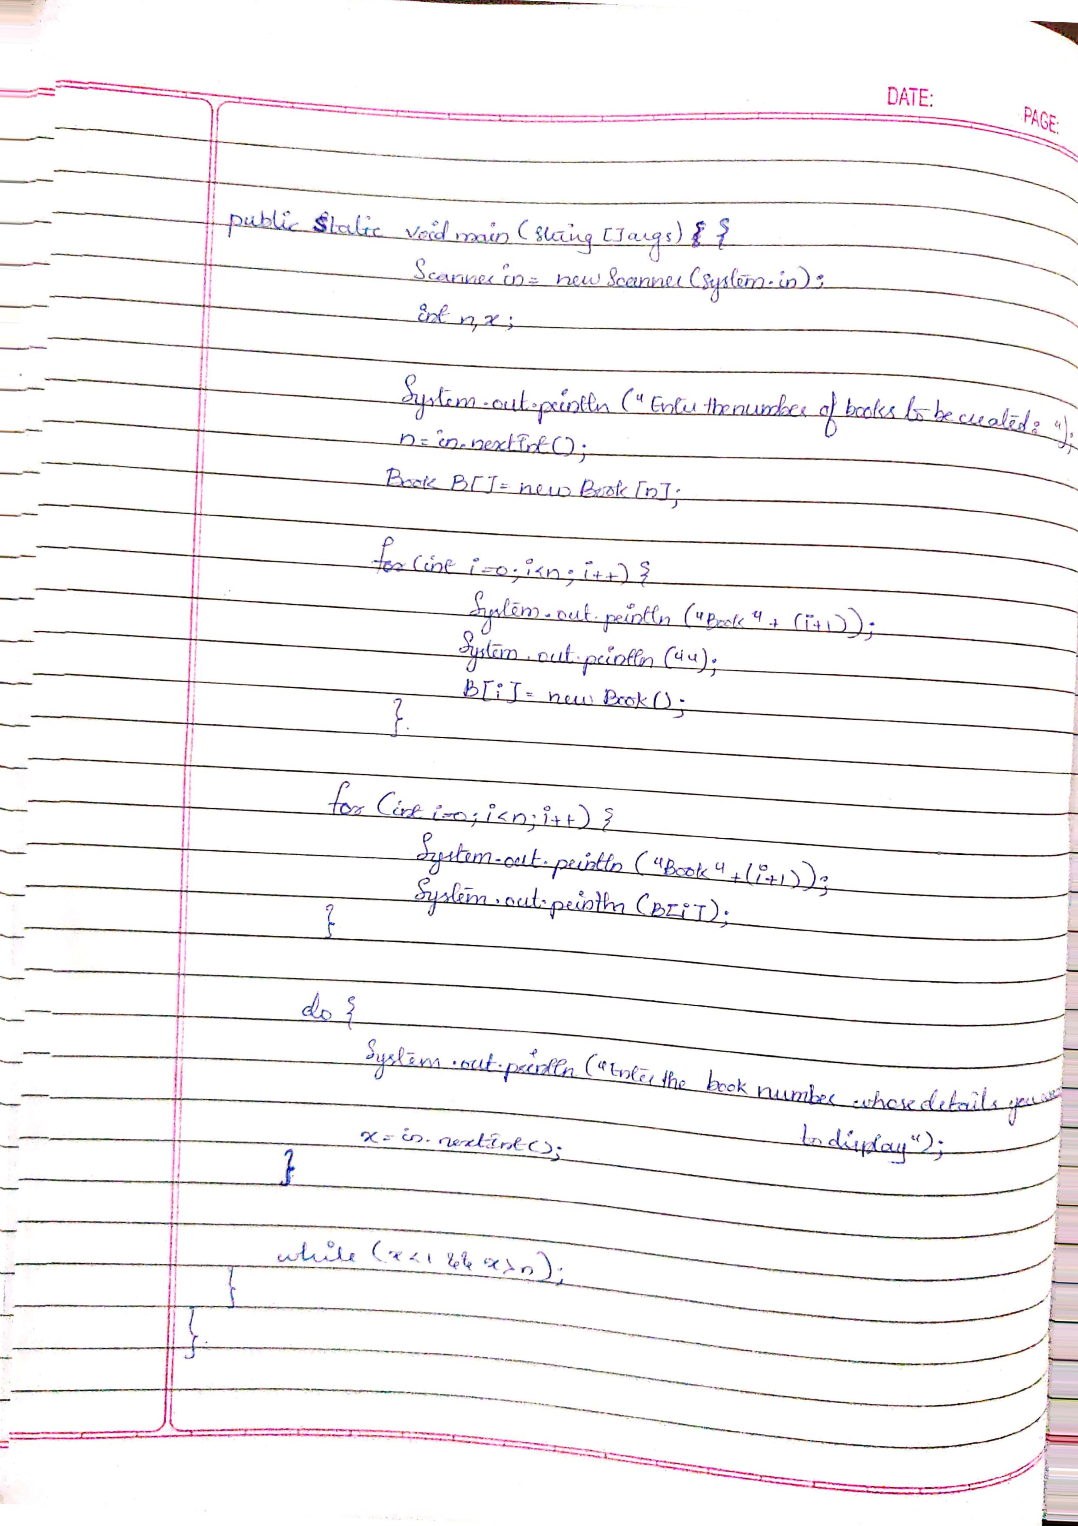

LAB4_AbstractClass

import java.util.*;

import java.lang.*;

abstract class Shape{

Scanner in = new Scanner(System.in);

int x1, x2;

Shape(){

System.out.println("Enter two numbers:");

System.out.println("");

x1=in.nextInt();

x2=in.nextInt();

}

abstract void printarea();

}

class Rectangle extends Shape{

void printarea(){

System.out.println("Area of Rectangle: " + (x1 * x2));

}

}

class Triangle extends Shape{

void printarea(){

System.out.println("Area of Triangle: " + (x1 * x2)/2);

}

}

class Circle extends Shape{

void printarea(){

System.out.println("Area of Circle 1: " + (3.14 * x1 * x1));

System.out.println("Area of Circle 2: " + (3.14 * x2 * x2));

}

}

class Abstract{

public static void main(String[]args){

Shape s;

s = new Rectangle();

s.printarea();

s = new Triangle();

s.printarea();

s = new Circle();

s.printarea();

}

}

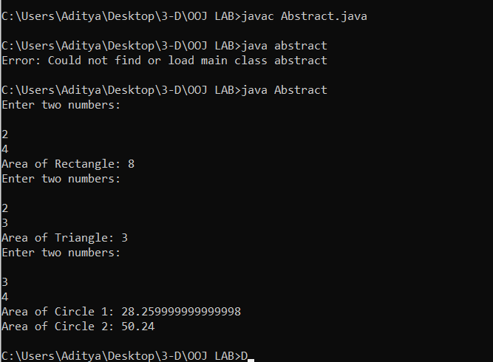

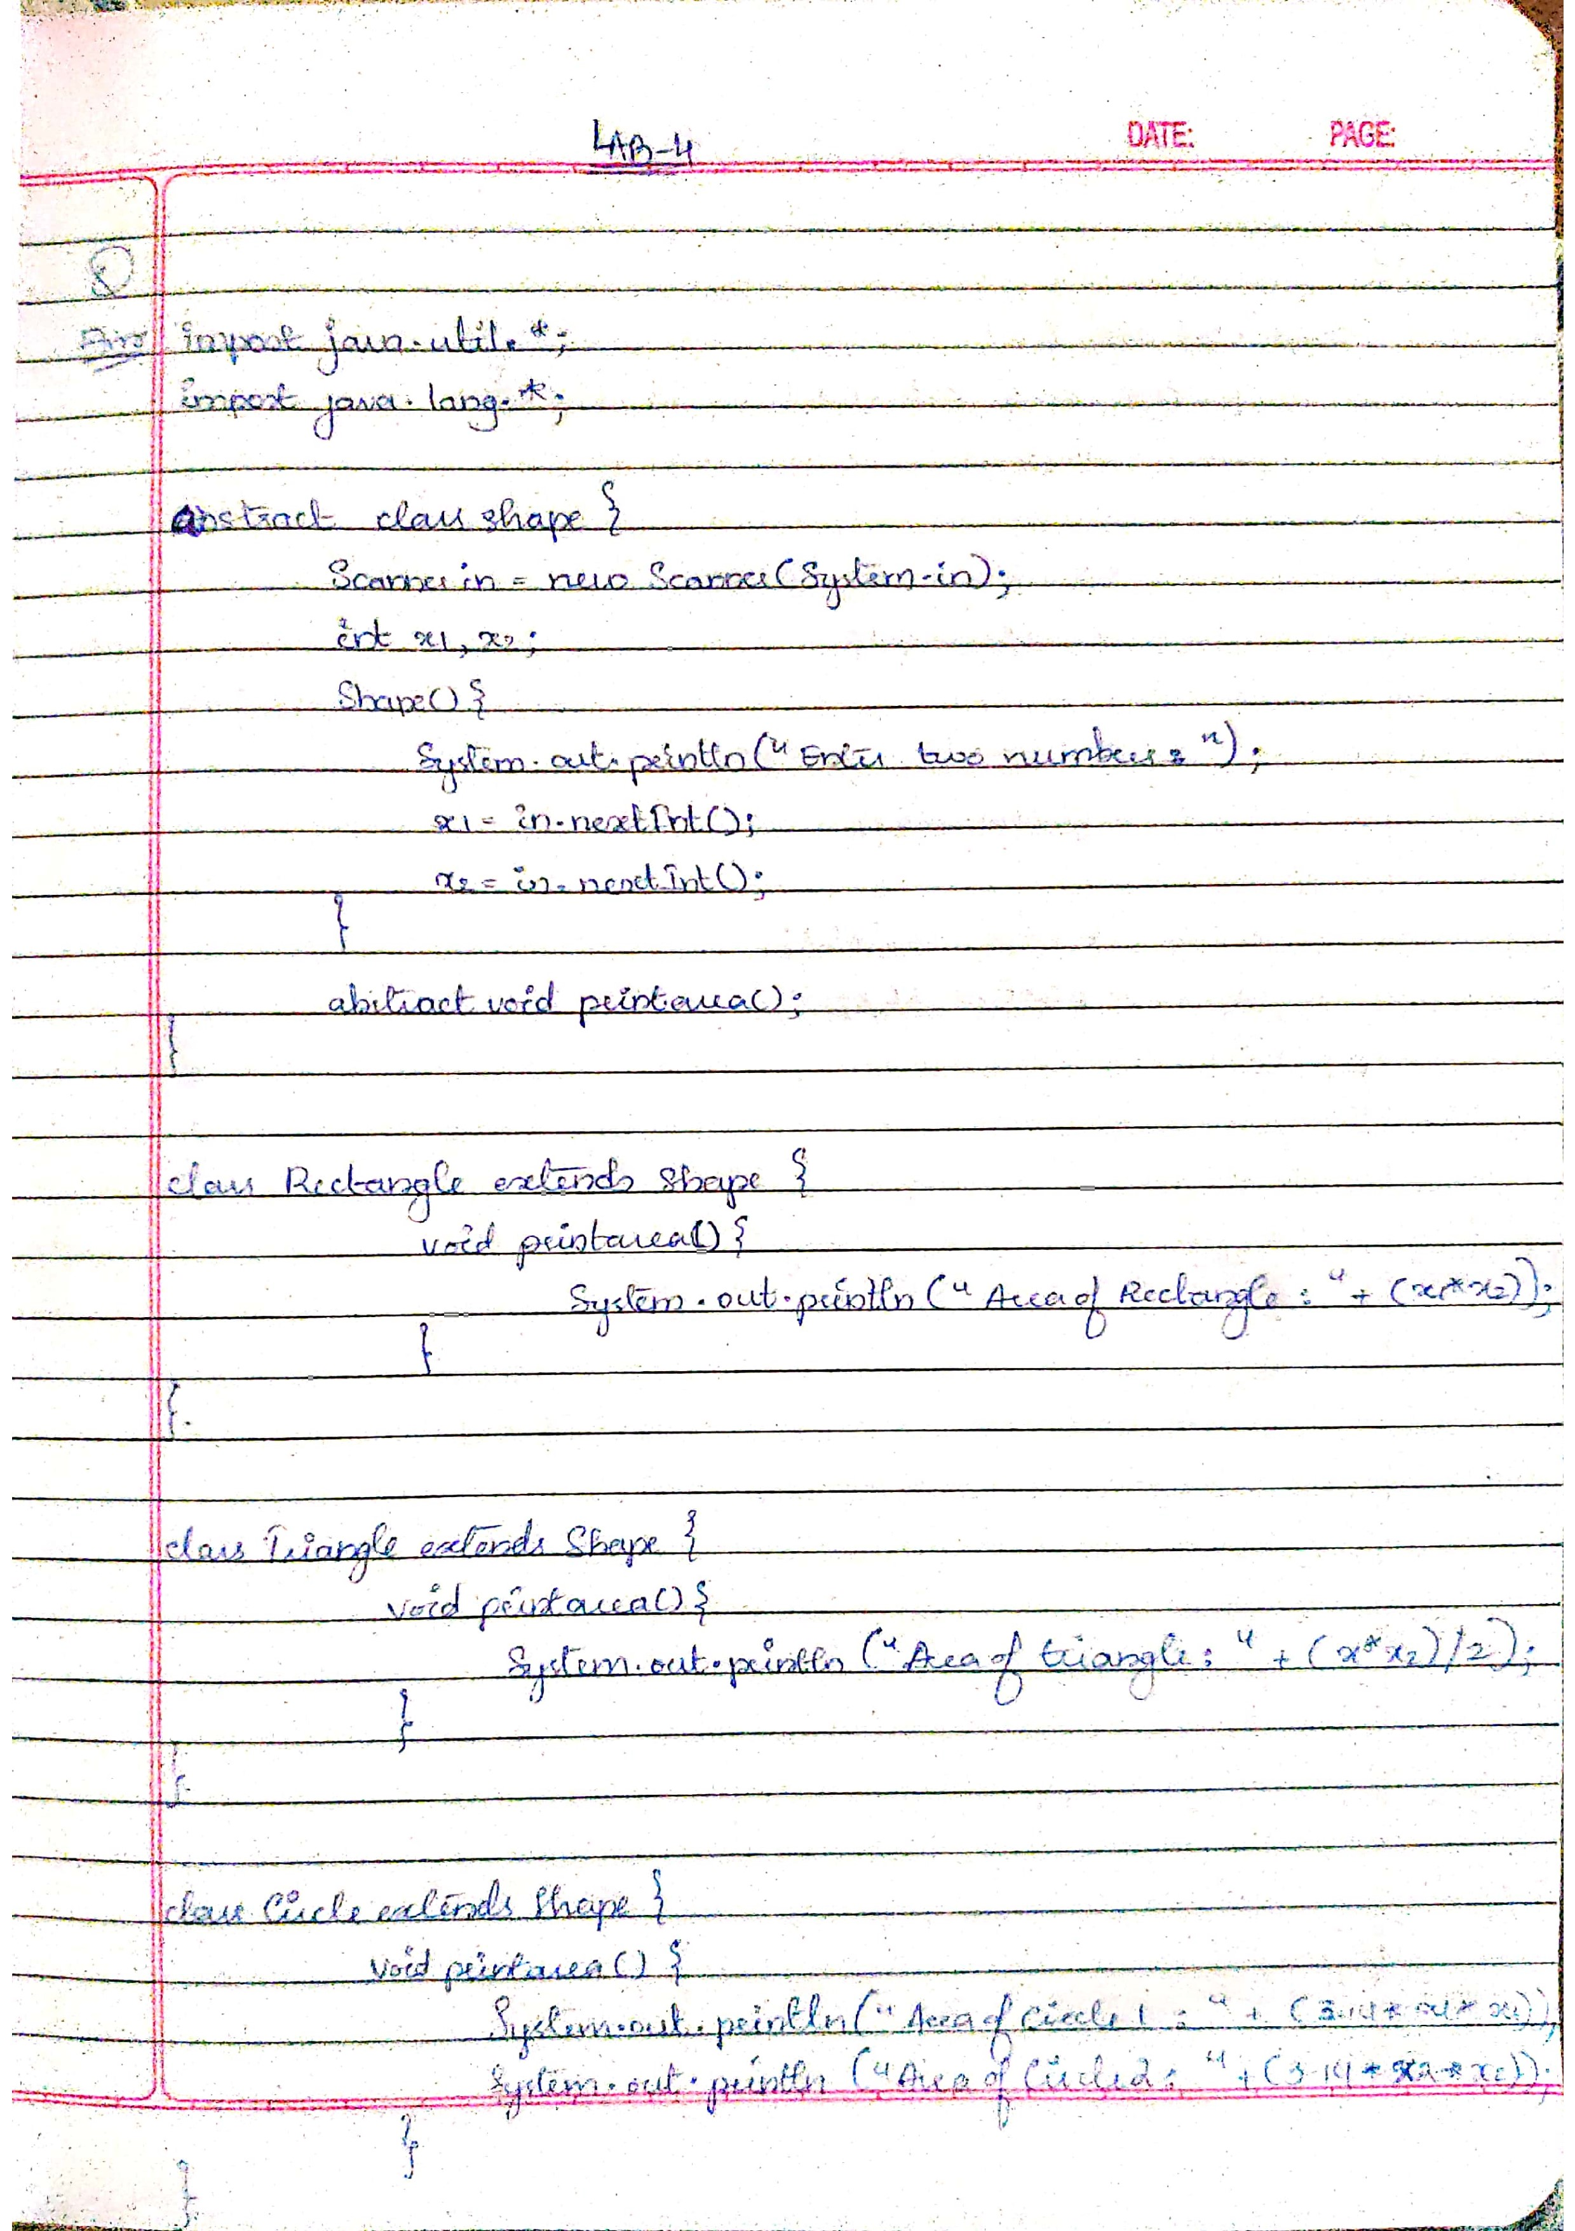

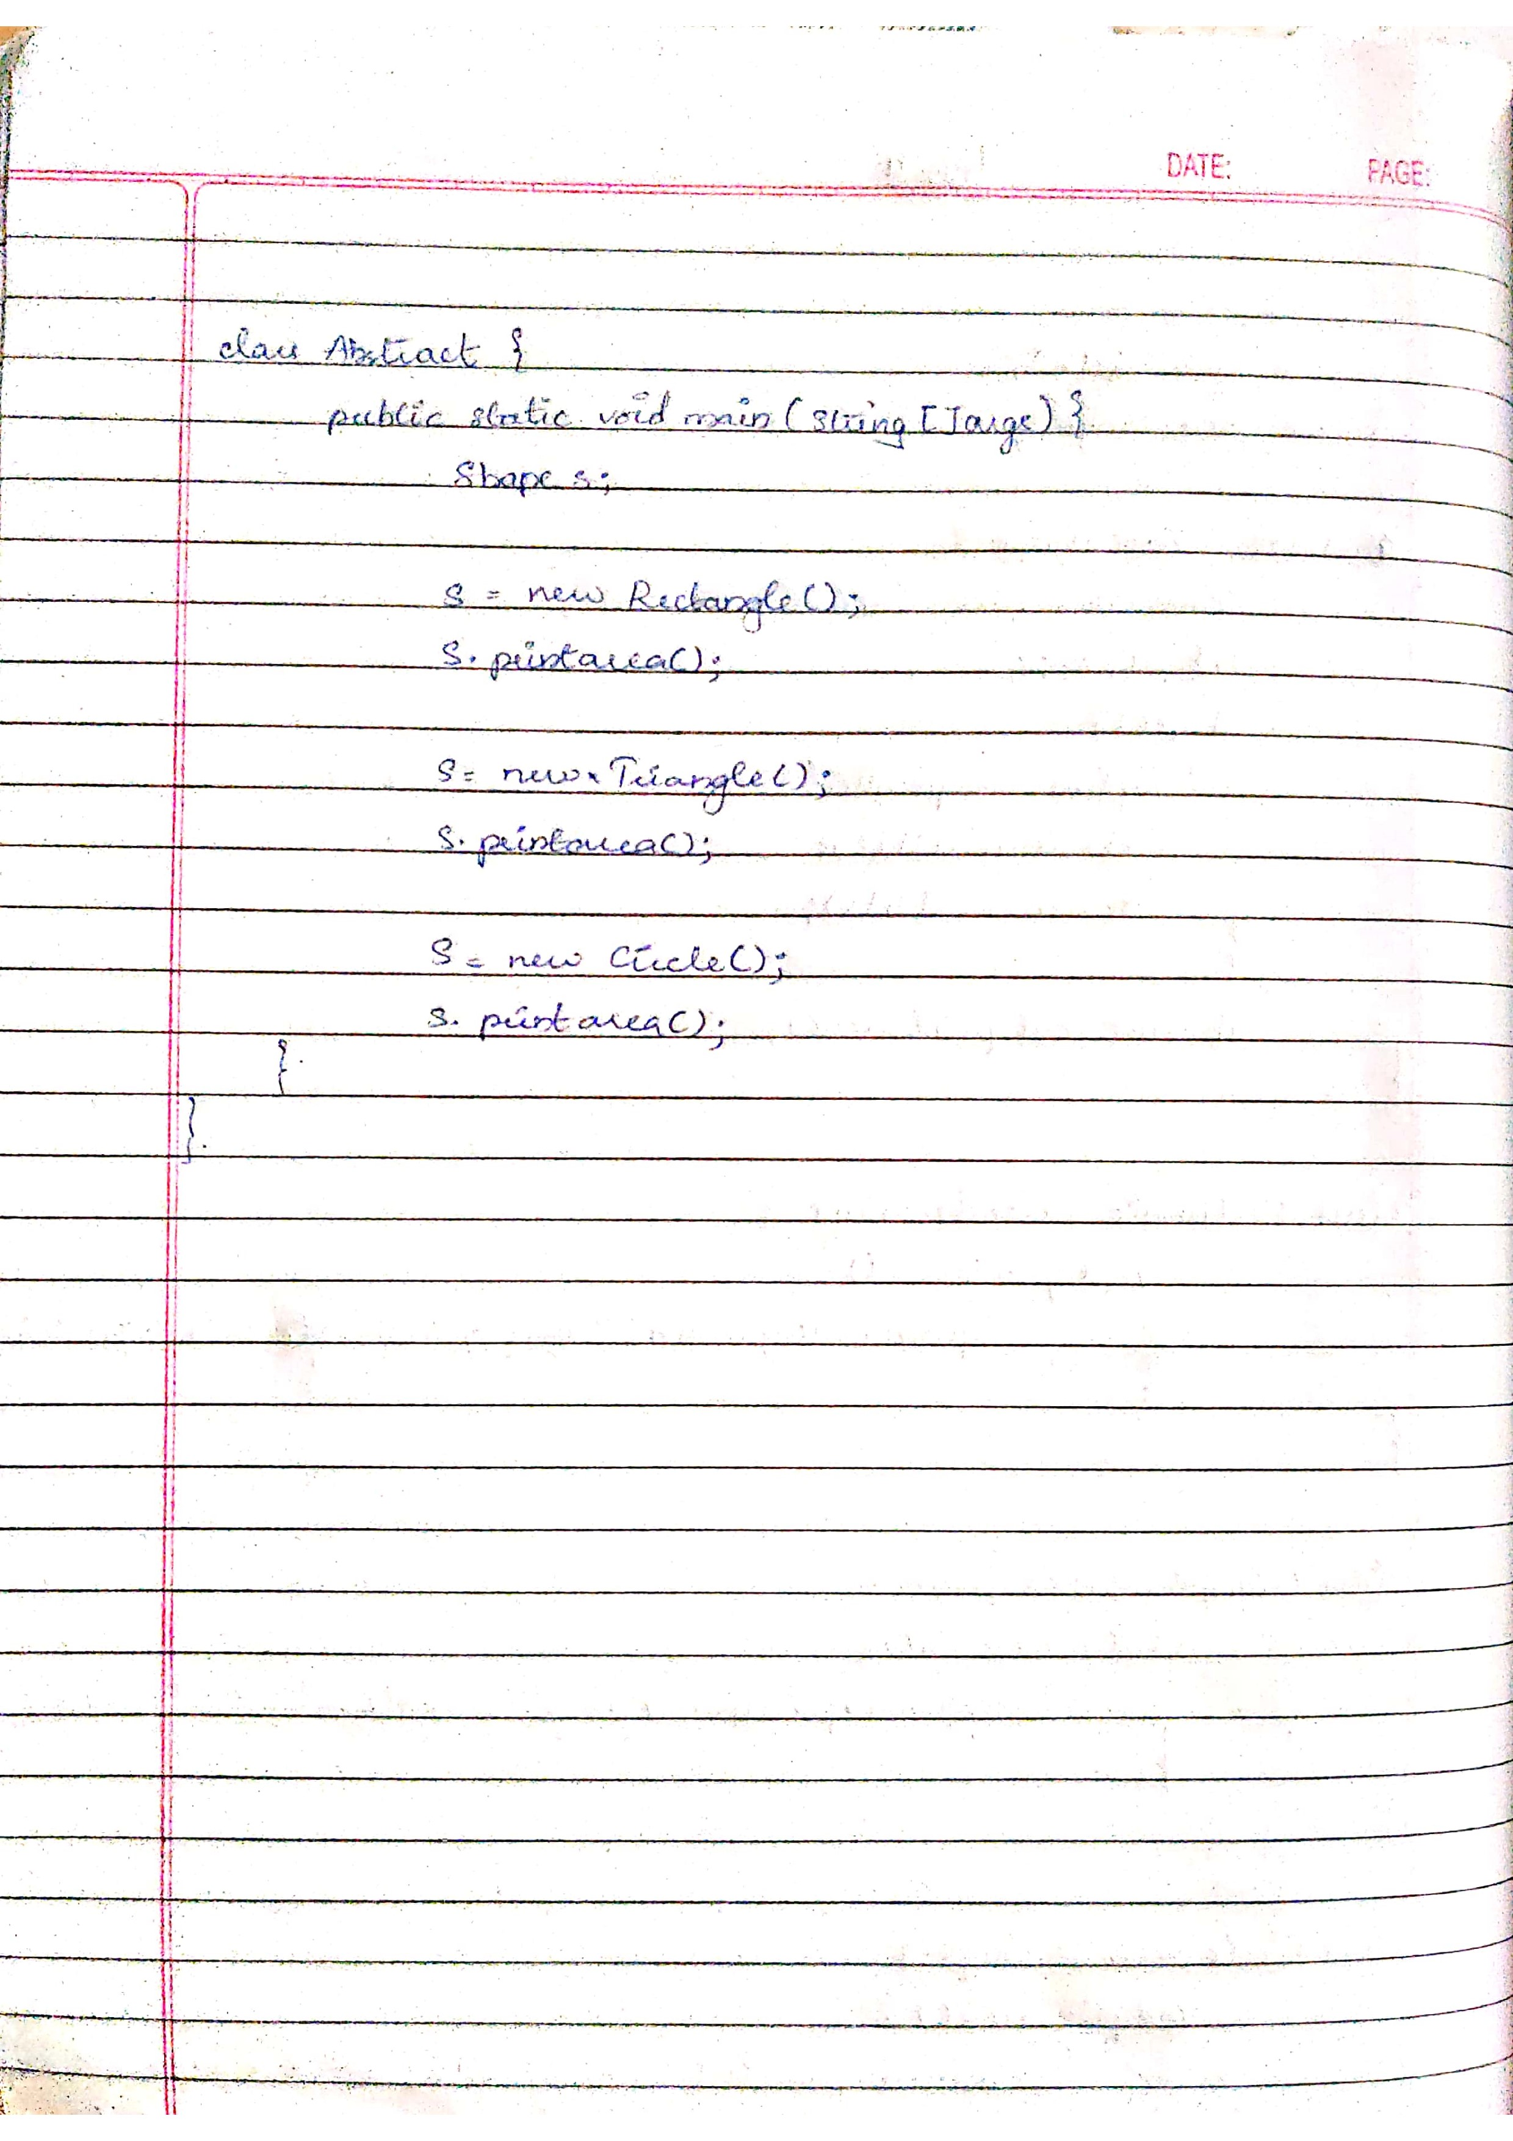

LAB5_BankDetails

import java.util.*;

import java.lang.*;

class Bank{

String name, abc;

int accNo;

char accType;

double balance = 0;

double deposit;

double chequeAmount;

Scanner in = new Scanner(System.in);

void inputData() {

System.out.println("Enter your account type (Savings/Current):");

abc = in.nextLine();

accType = abc.charAt(0);

}

void deposit() {

System.out.println("Enter an amount to deposit: ");

deposit = in.nextDouble();

balance += deposit;

System.out.println("Balance has been updated ");

System.out.println("");

}

void viewBalance(){

System.out.println("Balance = " + balance);

System.out.println("");

}

public static void main(String[]args){

Scanner s = new Scanner(System.in);

int x;

Bank a1 = new Bank();

a1.inputData();

if(a1.accType == 'C' || a1.accType == 'c'){

Current a2 = new Current();

do{

System.out.println("WELCOME TO YOUR CURRENT ACCOUNT");

System.out.println("");

System.out.println("(1) Deposit ");

System.out.println("(2) Check balance ");

System.out.println("(3) Issue Cheque ");

System.out.println("(4) Exit");

System.out.println("Enter your choice: ");

x = s.nextInt();

System.out.println("");

switch(x){

case 1: a2.deposit();

break;

case 2: a2.checkBalance();

break;

case 3: a2.issueCheque();

break;

case 4: System.exit(0);

break;

default: System.out.println("ERROR. INVALID CHOICE.");

}

}

while(x <= 4 && x >= 1);

}

else if (a1.accType == 'S' || a1.accType == 's'){

Savings a3 = new Savings();

do{

System.out.println("WELCOME TO YOUR SAVINGS ACCOUNT");

System.out.println("(1) Deposit");

System.out.println("(2) View balance");

System.out.println("(3) Withdraw ");

System.out.println("(4) Calculate compound interest ");

System.out.println("(5) Exit ");

System.out.println("Enter your choice: ");

x = s.nextInt();

System.out.println("");

switch(x){

case 1: a3.deposit();

break;

case 2: a3.viewBalance();

break;

case 3: a3.balanceAfterWithdrawal();

break;

case 4: a3.computeCI();

break;

case 5: System.exit(0);

break;

default: System.out.println("ERROR. INVALID CHOICE.");

}

}

while(x <= 5 && x >=1);

}

else System.out.println("INVALID ACCOUNT TYPE");

}

}

class Current extends Bank {

Current(){

System.out.println("Enter your name: ");

name = in.nextLine();

System.out.println("");

System.out.println("Enter your account number: ");

accNo = in.nextInt();

System.out.println("");

deposit();

}

void issueCheque(){

System.out.println("Enter amount for which cheque is to be issued.");

chequeAmount = in.nextDouble();

System.out.println("");

if(chequeAmount > balance){

System.out.println("ERROR! Insufficient amount in your account.");

}

else{

balance -= chequeAmount;

System.out.println("Cheque has been issued SUCCESSFULLY");

System.out.println("");

}

}

void checkBalance(){

if(balance < 1000){

System.out.println("Current available balance is lesser than minimum required balance.");

balance -= 100;

System.out.println("Service charge of Rs.100 has been deducted from your balance.");

}

viewBalance();

}

}

class Savings extends Bank{

double CI, withdrawalAmount, time;

Savings(){

System.out.println("Enter your name: ");

name = in.nextLine();

System.out.println("");

System.out.println("Enter your account number: ");

accNo = in.nextInt();

System.out.println("");

deposit();

}

void computeCI() {

System.out.println("Enter time period: ");

time = in.nextInt();

System.out.println("");

CI = balance * Math.pow(1 + (0.08 / 12), 12 * time) - balance;

System.out.println("CI = " + CI);

balance += CI;

System.out.println("CI has been deposited");

}

void balanceAfterWithdrawal(){

System.out.println("Enter the amount you want to withdraw: ");

withdrawalAmount = in.nextDouble();

if(withdrawalAmount > balance){

System.out.println("ERROR! The entered amount is greater than the available balance...");

}

else {

balance -= withdrawalAmount;

System.out.println("Amount has been successfully withdrawn!!!!");

}

}

}

